**Instructions for Consumer Notification of Lead, Galvanized Requiring Replacement or Lead Status Unknown Service Line**

Beginning October 16, 2024, all community and non-transient non-community water systems must inform their consumers at the service connection where the status of the service line is either lead, galvanized requiring replacement, or lead status unknown service lines ([40 CFR 141.85(e)](https://www.ecfr.gov/current/title-40/section-141.85#p-141.85(e))).

To comply with this provision, water systems must:

* provide initial notification to affected consumers by November 15, 2024.
* provide the appropriate notification to new customers prior to or at the time service begins.
* repeat the notification annually until the service line is no longer lead, galvanized requiring replacement, or lead status unknown.

The notification must include:

* the material status of the consumer's service line determined per [§ 141.84(a)](https://www.ecfr.gov/current/title-40/section-141.84#p-141.84(a)),
* an explanation of the health effects of lead,
* steps consumers can take to reduce exposure to lead in drinking water as specified in [§141.85(a)(1)(iv)](https://www.ecfr.gov/current/title-40/part-141#p-141.85(a)(1)(iv)),
* information about opportunities for service line replacement (consumer with a lead service line or galvanized service line requiring replacement only),
* information about opportunities for service line material identification (consumers with a lead status unknown service line only).

The following templates have been developed to ensure the consumer notifications meet all requirements under the LCRR ([40 CFR 141.85(e)(3)](https://www.ecfr.gov/current/title-40/part-141/section-141.85#p-141.85(e)(3)).Water systems cannot change *the information in italics* with an asterisk (*) on each end on the template and must include it as is. **The information in bold text** must be covered but water systems can modify the suggested language as appropriate. Anything in regular text is optional information.

Community water systems must deliver the notification to all affected consumers by mail, e-mail, or other direct delivery such as hand delivery. Non-transient non-community (NTNC) water systems must provide notice by posting the notice in conspicuous locations, and by any other method(s) reasonably calculated to reach other persons served by the system if they would not normally be reached by posting. NTNC schools must provide the notice to all staff, students, and parents/guardians.

For water systems serving a large proportion of non-English speaking consumers, this notice must have information in the appropriate language(s) or information on how to receive a translated copy of the notice or contact information on how to request assistance in the appropriate language.

If you have any questions about this consumer notification, contact your local health department.

**IMPORTANT INFORMATION: YOUR DRINKING WATER SERVICE LINE HAS BEEN IDENTIFIED AS LEAD**

**The [Insert Water System Name] has identified that a part of or the entire length of the service line that delivers drinking water to your house/building is made of lead.**

What is a Lead Service Line?

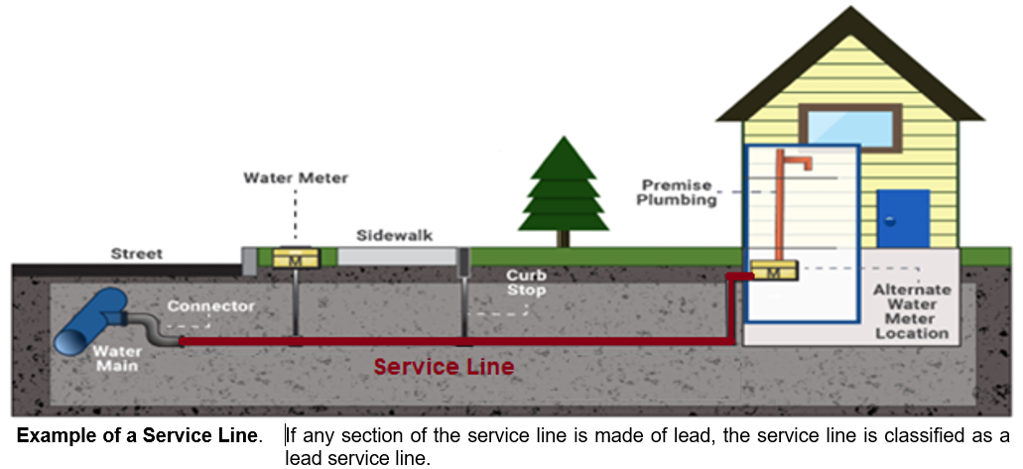A service line is the pipe connecting the water main to the building inlet. A typical configuration of a service line is shown in the figure. [Insert system-specific information, for example, our system owns the service line from the water main to a curb stop and property owners own the service line from the curb stop to the building inlet; or in our system, property owners own the entire length of a service line.] When any section of the service line is made of lead, it is a lead service line.

What Does It Mean?

Having a lead service line doesn’t necessarily mean your drinking water contains an elevated level of lead. However, a lead service line has been identified as a source of lead and may contribute to lead in drinking water. This can happen when the characteristics of water (for example, low pH) increase the corrosion of lead pipes. Removing the lead service line is a sure way to reduce your chance of exposure to lead in drinking water.

Source of Lead in Drinking Water

Lead enters drinking water from a lead service line and indoor plumbing materials such as lead solder on copper pipes and chrome-plated brass or brass fixtures and faucets.

**Health Effects of Lead**

*\*Exposure to lead in drinking water can cause serious health effects in all age groups. Infants and children can have decreases in IQ and attention span. Lead exposure can lead to new learning and behavior problems or exacerbate existing learning and behavior problems. The children of women who are exposed to lead before or during pregnancy can have increased risk of these adverse health effects. Adults can have increased risks of heart disease, high blood pressure, kidney or nervous system problems.\**

**Steps You Can Take to Reduce Your Exposure to Lead in Drinking Water**

* **Use your filter properly**. Using a filter can reduce lead in drinking water. If you use a filter, it should be certified to remove lead. Read any directions provided with the filter to learn how to properly install, maintain, and use your cartridge and when to replace it. Using the cartridge after it has expired can make it less effective at removing lead. Do not run hot water through the filter. For more information on facts and advice on home water filtration systems, visit EPA’s website at <https://www.epa.gov/ground-water-and-drinking-water/home-drinking-water-filtration-fact-sheet>and EPA’s [Consumer Tool for Identifying Drinking Water Filters Certified to Reduce Lead.](https://www.epa.gov/sites/default/files/2018-12/documents/consumer_tool_for_identifying_drinking_water_filters_certified_to_reduce_lead.pdf)
* **Clean your aerator.** Regularly remove and clean your faucet’s screen (also known as an aerator). Sediment, debris, and lead particles can collect in your aerator. If lead particles are caught in the aerator, lead can get into your water.
* **Use cold water**. Do not use hot water from the tap for drinking, cooking, or making baby formula as lead dissolves more easily into hot water. Boiling water does not remove lead from water.
* **[Areas prone to drought or currently experiencing scarcity of water may want to omit or edit this recommendation.]** **Run your water.** The more time water has been sitting in your home’s pipes, the more lead it may contain. Before drinking, flush your home’s pipes by running the tap, taking a shower, doing laundry, or doing a load of dishes. The amount of time to run the water will depend on whether your home has a lead service line or not, as well as the length and diameter of the service line and the amount of plumbing in your home. **[Include tailored flushing information, if appropriate, or add following language]** Residents may contact us at **[phone number and/or email address]** for recommendations about flushing times in their community.
* **Learn what your service line material is.** Contact us at **[phone number and/or email address]** or a licensed plumber to determine if the pipe that connects your home to the water main (called a service line) is made from lead, galvanized, or other materials. **[For systems replacing lead service lines consider the following text.]** To find out aboutwhat we are doing to replace lead service lines, please visit **[website]** or contact us at **[phone number and/or email address]**. [Protect Your Tap: A quick check for lead](https://www.epa.gov/ground-water-and-drinking-water/protect-your-tap-quick-check-lead-0) is EPA’s on-line step by step guide to learn how to find lead pipes in your home.
* **Learn about construction in your neighborhood.** Contact us at **[phone number and/or email address]** to find out about any construction or maintenance work that could disturb your service line. Construction may cause more lead to be released from a lead service line if present.
* **Have your water tested.** Contact us at **[phone number and/or email address]** to have your water tested and to learn more about the lead levels in your drinking water.

Get Your Child Tested to Determine Lead Levels in their Blood

A family doctor or pediatrician can perform a blood test for lead and provide information about the health effects of lead. State, city, or county departments of health can also provide information about how you can have your child's blood tested for lead. The Centers for Disease Control and Prevention recommends public health actions when the level of lead in a child’s blood is 3.5 micrograms per deciliter (µg/dL) or more. For more information and links to CDC’s website, please visit <https://www.epa.gov/ground-water-and-drinking-water/basic-information-about-lead-drinking-water>.

**Opportunities to Replace Your Lead Service Line**

**We are required to replace the portion of a lead service line we own when property owners notify us that they are replacing their portion of the lead service line.** Please contact us at [Insert contact information of your system] before replacing your lead service line.

**[Insert information about opportunities available to property owners to replace their lead service lines as well as financing programs available to assist property owners with the cost of replacing their lead service line.**

We are also responsible for maintaining an inventory of all service lines, so keep us updated if your service line changes.

**If you have any questions about your service line, call us at** **[insert phone number] or (if applicable) visit our website at** **[insert website]. For more information on lead in drinking water, contact your local health department at** **[insert local health department or district office name, phone number, and email address].**

This notice is brought to you by **[insert the name of your water system]**

State Water System ID# **[insert your water system’s ID number]**

Date: **[Insert the date distributed]**

**IMPORTANT INFORMATION: YOUR DRINKING WATER SERVICE LINE HAS BEEN IDENTIFIED AS GALVANIZED REQUIRING REPLACEMENT**

**The [Insert Water System Name] has identified a part of your service line is made of galvanized steel that needs replacement.**

What is a Galvanized Service Line Requiring Replacement (GSLRR)?

A service line is the pipe connecting the water main to the building inlet. A typical configuration of a service line is shown in the figure. [Insert system-specific information: example option 1, our system owns the service line from the water main to a curb stop and property owners own the service line from the curb stop to the building inlet; example option 2, in our system, property owners own the entire length of a service line.] A GSLRR is a service line that is made of galvanized steel and:

* was downstream of a lead service line, or
* was downstream of an unknown material, or
* 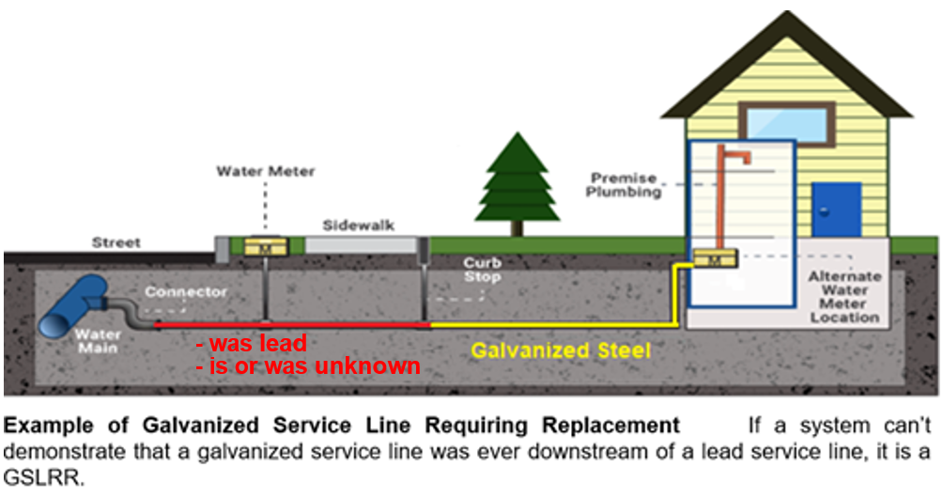is downstream of an unknown material.

What Does It Mean?

Either we replaced the lead service line, or we don’t know if there is or was a lead service line upstream of your galvanized service line. A galvanized service line is a potential source of lead as it can absorb lead from a lead service line and release it to drinking water later.

Source of Lead in Drinking Water

Lead enters drinking water from a lead service line and indoor plumbing materials such as lead solder on copper pipes and chrome-plated brass or brass fixtures and faucets.

**Health Effects of Lead**

*\*Exposure to lead in drinking water can cause serious health effects in all age groups. Infants and children can have decreases in IQ and attention span. Lead exposure can lead to new learning and behavior problems or exacerbate existing learning and behavior problems. The children of women who are exposed to lead before or during pregnancy can have increased risk of these adverse health effects. Adults can have increased risks of heart disease, high blood pressure, kidney or nervous system problems.\**

**Steps You Can Take to Reduce Your Exposure to Lead in Drinking Water**

* **Use your filter properly**. Using a filter can reduce lead in drinking water. If you use a filter, it should be certified to remove lead. Read any directions provided with the filter to learn how to properly install, maintain, and use your cartridge and when to replace it. Using the cartridge after it has expired can make it less effective at removing lead. Do not run hot water through the filter. For more information on facts and advice on home water filtration systems, visit EPA’s website at <https://www.epa.gov/ground-water-and-drinking-water/home-drinking-water-filtration-fact-sheet>and EPA’s [Consumer Tool for Identifying Drinking Water Filters Certified to Reduce Lead.](https://www.epa.gov/sites/default/files/2018-12/documents/consumer_tool_for_identifying_drinking_water_filters_certified_to_reduce_lead.pdf)
* **Clean your aerator.** Regularly remove and clean your faucet’s screen (also known as an aerator). Sediment, debris, and lead particles can collect in your aerator. If lead particles are caught in the aerator, lead can get into your water.
* **Use cold water**. Do not use hot water from the tap for drinking, cooking, or making baby formula as lead dissolves more easily into hot water. Boiling water does not remove lead from water.
* **[Areas prone to drought or currently experiencing scarcity of water may want to omit or edit this recommendation.]** **Run your water.** The more time water has been sitting in your home’s pipes, the more lead it may contain. Before drinking, flush your home’s pipes by running the tap, taking a shower, doing laundry, or doing a load of dishes. The amount of time to run the water will depend on whether your home has a lead service line or not, as well as the length and diameter of the service line and the amount of plumbing in your home. **[Include tailored flushing information, if appropriate, or add following language]** Residents may contact us at **[phone number and/or email address]** for recommendations about flushing times in their community.
* **Learn what your service line material is.** Contact us at **[phone number and/or email address]** or a licensed plumber to determine if the pipe that connects your home to the water main (called a service line) is made from lead, galvanized, or other materials. **[For systems replacing lead service lines consider the following text.]** To find out aboutwhat we are doing to replace lead service lines, please visit **[website]** or contact us at **[phone number and/or email address]**. [Protect Your Tap: A quick check for lead](https://www.epa.gov/ground-water-and-drinking-water/protect-your-tap-quick-check-lead-0) is EPA’s on-line step by step guide to learn how to find lead pipes in your home.
* **Learn about construction in your neighborhood.** Contact us at **[phone number and/or email address]** to find out about any construction or maintenance work that could disturb your service line. Construction may cause more lead to be released from a lead service line if present.
* **Have your water tested.** Contact us at **[phone number and/or email address]** to have your water tested and to learn more about the lead levels in your drinking water.

Get Your Child Tested to Determine Lead Levels in their Blood

A family doctor or pediatrician can perform a blood test for lead and provide information about the health effects of lead. State, city, or county departments of health can also provide information about how you can have your child's blood tested for lead. The Centers for Disease Control and Prevention recommends public health actions when the level of lead in a child’s blood is 3.5 micrograms per deciliter (µg/dL) or more. For more information and links to CDC’s website, please visit <https://www.epa.gov/ground-water-and-drinking-water/basic-information-about-lead-drinking-water>.

**Opportunities to Verify Your Service Line Material**

[**[Insert information on opportunities available to customers to replace their galvanized service line requiring replacement.]**

We are also responsible for maintaining an inventory of all service lines, so keep us updated if your service line changes.

**If you have any questions about your service line, call us at [insert phone number] or (if applicable) visit our website at [insert website]. For more information on lead in drinking water, contact your local health department at [insert local health department or district office name, phone number, and email address].**

This notice is brought to you by **[insert the name of your water system]**

State Water System ID# **[insert your water system’s ID number]**

Date: **[Insert the date distributed]**

**IMPORTANT INFORMATION: YOUR DRINKING WATER SERVICE LINE LEAD STATUS IS UNKNOWN**

**The [Insert Water System Name] has not yet identified what your service line is made of. All or a part of your service line may be made of lead.**

What is a Lead Status Unknown Service Line?

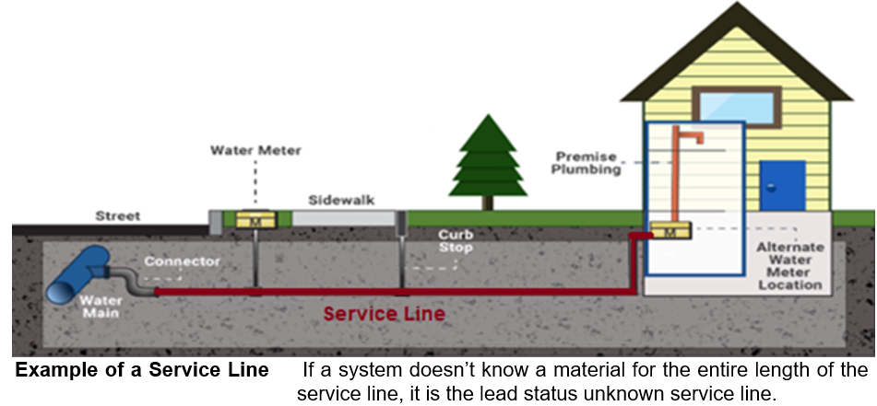A service line is the pipe connecting the water main to the building inlet. A typical configuration of a service line is shown here. [Insert system-specific information, for example, our system owns the service line from the water main to a curb stop and property owners own the service line from the curb stop to the building inlet; or in our system, property owners own the entire length of a service line.] When any section of the service line material is unknown, we need to categorize it as a lead status unknown service line.

What Does It Mean?

We don’t know what your service line or portion of it is made of. Until we can confirm that the entire length of your service line is not made of lead, we will continue to provide information about lead in drinking water once a year, so you can take precautionary measures to minimize your potential exposure to lead in drinking water.

Source of Lead in Drinking Water

Lead enters drinking water from a lead service line and indoor plumbing materials such as lead solder on copper pipes and chrome-plated brass or brass fixtures and faucets.

**Health Effects of Lead**

*\*Exposure to lead in drinking water can cause serious health effects in all age groups. Infants and children can have decreases in IQ and attention span. Lead exposure can lead to new learning and behavior problems or exacerbate existing learning and behavior problems. The children of women who are exposed to lead before or during pregnancy can have increased risk of these adverse health effects. Adults can have increased risks of heart disease, high blood pressure, kidney or nervous system problems.\**

**Steps You Can Take to Reduce Your Exposure to Lead in Drinking Water**

* **Use your filter properly**. Using a filter can reduce lead in drinking water. If you use a filter, it should be certified to remove lead. Read any directions provided with the filter to learn how to properly install, maintain, and use your cartridge and when to replace it. Using the cartridge after it has expired can make it less effective at removing lead. Do not run hot water through the filter. For more information on facts and advice on home water filtration systems, visit EPA’s website at <https://www.epa.gov/ground-water-and-drinking-water/home-drinking-water-filtration-fact-sheet>and EPA’s [Consumer Tool for Identifying Drinking Water Filters Certified to Reduce Lead.](https://www.epa.gov/sites/default/files/2018-12/documents/consumer_tool_for_identifying_drinking_water_filters_certified_to_reduce_lead.pdf)
* **Clean your aerator.** Regularly remove and clean your faucet’s screen (also known as an aerator). Sediment, debris, and lead particles can collect in your aerator. If lead particles are caught in the aerator, lead can get into your water.
* **Use cold water**. Do not use hot water from the tap for drinking, cooking, or making baby formula as lead dissolves more easily into hot water. Boiling water does not remove lead from water.
* **[Areas prone to drought or currently experiencing scarcity of water may want to omit or edit this recommendation.]** **Run your water.** The more time water has been sitting in your home’s pipes, the more lead it may contain. Before drinking, flush your home’s pipes by running the tap, taking a shower, doing laundry, or doing a load of dishes. The amount of time to run the water will depend on whether your home has a lead service line or not, as well as the length and diameter of the service line and the amount of plumbing in your home. **[Include tailored flushing information, if appropriate, or add following language]** Residents may contact us at **[phone number and/or email address]** for recommendations about flushing times in their community.
* **Learn what your service line material is.** Contact us at **[phone number and/or email address]** or a licensed plumber to determine if the pipe that connects your home to the water main (called a service line) is made from lead, galvanized, or other materials. **[For systems replacing lead service lines consider the following text.]** To find out aboutwhat we are doing to replace lead service lines, please visit **[website]** or contact us at **[phone number and/or email address]**. [Protect Your Tap: A quick check for lead](https://www.epa.gov/ground-water-and-drinking-water/protect-your-tap-quick-check-lead-0) is EPA’s on-line step by step guide to learn how to find lead pipes in your home.
* **Learn about construction in your neighborhood.** Contact us at **[phone number and/or email address]** to find out about any construction or maintenance work that could disturb your service line. Construction may cause more lead to be released from a lead service line if present.
* **Have your water tested.** Contact us at **[phone number and/or email address]** to have your water tested and to learn more about the lead levels in your drinking water.

Get Your Child Tested to Determine Lead Levels in their Blood

Although there is no confirmation of having a lead service line, you may wish to speak with a healthcare provider to see if your child’s blood lead level is elevated and/or if there is a need for blood testing, if you are concerned about potential exposure. For more information on these actions, please visit <https://www.cdc.gov/nceh/lead/advisory/acclpp/actions-blls.htm>.

**Opportunities to Verify Your Service Line Material**

**[Insert information on opportunities to verify the material of lead status unknown service line, such as scheduling a service line inspection at no cost to the customer or about how people can identify their service line materials.]**

We are also responsible for maintaining an inventory of all service lines, so keep us updated if your service line changes.

**If you have any questions about your service line, call us at [insert phone number] or (if applicable) visit our website at [insert website]. For more information on lead in drinking water, contact your local health department at [insert local health department or district office name, phone number, and email address].**

This notice is brought to you by **[insert the name of your water system]**

State Water System ID# **[insert your water system’s ID number]**

Date: **[Insert the date distributed]**